Payroll management system for information technology company

Version 1.0

Revision History

|  |  |  |  |
| --- | --- | --- | --- |
| **Date** | **Version** | **Description** | **Author** |
| 28/12/2019 | 1.0 | Final | Nguyen Khac Phuc |
|  |  |  |  |
|  |  |  |  |
|  |  |  |  |

Table of Contents

1. View all reports 4

1.1 Brief Description 4

2. Flow of Events 4

2.1 Basic Flow 4

2.2 Actor 4

3. Special Requirements 4

4. Preconditions 4

5. Postconditions 4

6. Extension Points 4

# View report

## Brief Description

This use-case defines the step of view the reports. Employee and Accountant can easily see the information of reports.

# Flow of Events

## Basic Flow

* Users log in with the employee or accountant account, they click view report button. After that, a table contains information of all the reports which have been sorted base on their date will be shown on the left. Employee or accountant enter the id of the specific report and click search for full details of that report which will be shown on the right of the view.

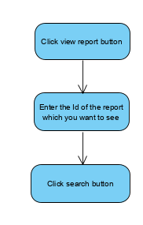

## Actor

-Employee, Accountant.

# Special Requirements

## Valid search.

-User must enter the id of the specific report before click search button to see the full information of that report.

# Preconditions

* User must log in into the system with the Employee or Accountant account

# Postconditions

* Show all the reports or show nothing if there is no report in the database.
* Show the specific report when find by id.

# Extension Points